Salt Security Rollout: AI Security Roadmap & Best Practices
Oct 26, 2026 · @Stas Kosovskiy

Executive summary
Roll out Salt Security in six phases over roughly 6 months: discover first, govern posture second, detect third, and block only after tuning. Salt's value for AI security is that it covers the agent "action layer" (MCP servers, tools, downstream APIs), not just the model.
Program goals
- Visibility: a single inventory of APIs, AI agents and MCP servers, including shadow and zombie assets.
- AI-SPM / posture: continuous detection of misconfigured APIs and MCP servers against agreed policies.
- AI Detection (AI-DR / AG-DR): runtime detection of prompt injection, jailbreaks and agent misuse, correlated to downstream API activity.
- Response: alerts routed to SOC and selective automated blocking via WAF.
In scope: production and pre-production API estate, LLM-backed applications, AI agents and MCP servers across cloud accounts and code repositories.
Out of scope (separate controls): model training data security, model supply chain scanning, and employee use of public GenAI tools.
Timelines below are planning estimates, not vendor commitments; validate them with Salt during kickoff.

Capability map
Salt covers four capability layers; each phase of the roadmap switches on one more layer.
Layer | Salt capability | What it gives us
Discovery | Cloud Connect (agentless, read-only), GitHub Connect, traffic sensors | API inventory incl. shadow/zombie APIs and sensitive data exposure
Agentic discovery | MCP Finder: external (Salt Surface), code (GitHub Connect), runtime (agent behavior mapping) | Registry of MCP servers, tools invoked and data flows
Posture (AI-SPM) | API and MCP posture management, spec drift vs OAS/Swagger | Policy violations across agents, MCP servers and LLM integrations
Runtime detection | Behavioral threat protection, Intent Analysis, AI-DR inside AG-DR | Prompt injection, jailbreaks, agents going off-script, BOLA, credential stuffing
Response | AWS WAF and CDN WAF blocking, SIEM/SOAR outbound | Alerting and blocking of attackers, not single transactions
The Agentic Security Graph ties these together: it links agents, models, MCP servers, tools and APIs, so an injected prompt can be traced to the API calls it triggered.

Phased roadmap
Six phases over about 26 weeks, overlapping where work can run in parallel. Each phase ends at a gate; do not move to blocking before detection is tuned.
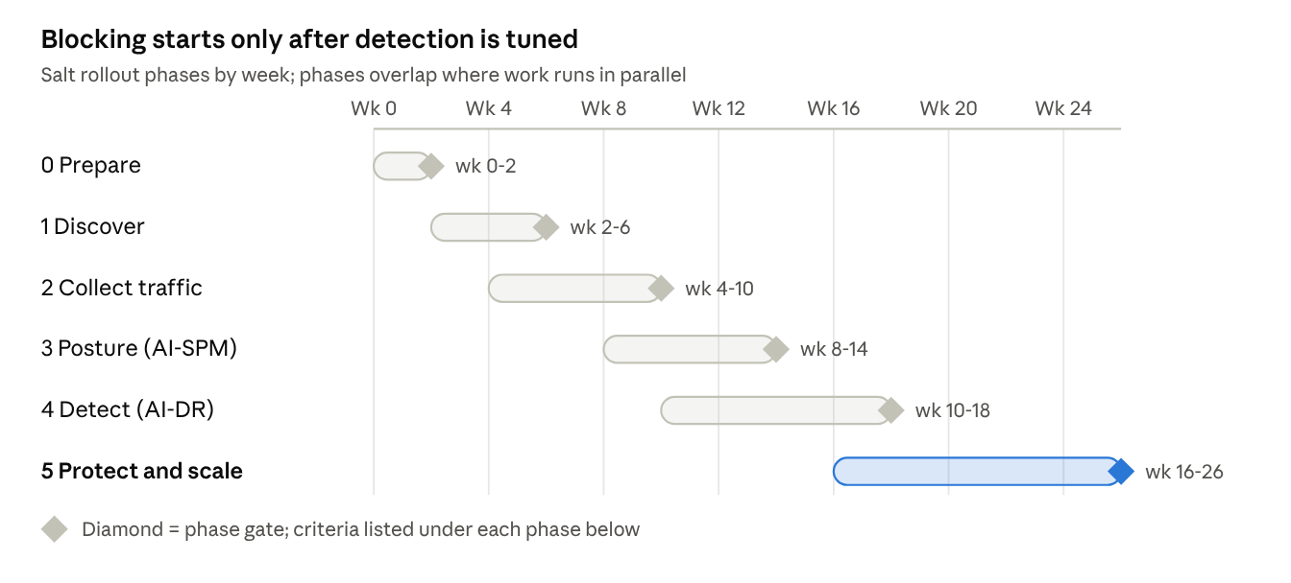
Salt rollout roadmap · 6 phases over 26 weeks
Discovery and traffic collection run in parallel early; WAF blocking (Phase 5) begins only after AI-DR tuning in Phase 4.

Phase 0 — Prepare (weeks 0–2)
- Name an executive sponsor, a Salt program owner and app-team champions.
- Agree scope: crown-jewel APIs, LLM-backed apps, agent platforms, MCP servers.
- Run privacy and data-handling review: Salt analyzes copies of API traffic, so confirm masking of PII/PHI, data residency and retention.
- Approve the deployment architecture and least-privilege cloud roles.
Gate: architecture, data-handling and access approvals signed.

Phase 1 — Discover (weeks 2–6)
- Connect cloud accounts with Cloud Connect (agentless, read-only).
- Connect source repositories with GitHub Connect to find APIs and MCP servers before deployment.
- Run external surface discovery for exposed APIs and MCP servers.
- Reconcile the inventory with the CMDB and assign an owner to every high-risk asset.
Gate: all in-scope accounts and repos connected; owners assigned for crown-jewel APIs and all discovered MCP servers.

Phase 2 — Collect traffic (weeks 4–10)
- Deploy collectors at existing choke points: API gateways, load balancers, Kubernetes, CDN workers.
- Start in non-production, then roll to production app by app.
- Let the behavioral baseline learn before judging detections.
Gate: traffic flowing for all priority apps; baseline period complete; no measurable latency impact.

Phase 3 — Posture / AI-SPM (weeks 8–14)
- Define posture policies (examples: authentication required on every MCP server, no sensitive data in responses, spec matches live traffic).
- Add posture checks to CI/CD and route findings to the ticketing system.
- Agree remediation SLAs by severity with engineering.
Gate: policies enforced in reporting; remediation SLAs live; posture baseline captured.

Phase 4 — Detect / AI-DR (weeks 10–18)
- Enable AI-DR / AG-DR for LLM apps and agent workflows.
- Bring existing AI guardrails and AI gateways into the Salt view.
- Integrate alerts with SIEM/SOAR and write SOC runbooks for AI attack types.
- Tune with app owners until alert quality is acceptable.
Gate: SOC runbooks signed off; false-positive rate within the agreed threshold.

Phase 5 — Protect and scale (weeks 16–26)
- Turn on WAF blocking for high-confidence attackers, starting with crown-jewel apps.
- Move app by app from monitor to block, with a rollback plan for each.
- Extend coverage to remaining apps, new clouds and new agent platforms.
- Hand over to steady-state operations with quarterly reviews.
Gate: blocking live on crown-jewel apps; steady-state ownership accepted.

Deployment and integration best practices
Start agentless, add traffic collection at existing choke points, and keep Salt out of the request path until blocking is justified.
Inbound (getting data in)
- Lead with Cloud Connect: read-only, least-privilege, and it can show posture before any traffic is collected.
- Collect traffic where it already converges: API gateways, load balancers, ingress controllers, CDN workers. Avoid per-service agents.
- On AWS, use VPC traffic mirroring for unencrypted dev/test traffic and ALB integration for encrypted traffic; sensors run on containers or EC2.
- Mirror only relevant traffic (APIs, LLM endpoints, MCP endpoints) to control bandwidth and cost.
- Mask or exclude sensitive fields at the collector before data leaves your environment.
- Connect every in-scope repository with GitHub Connect so MCP servers are found in code, not only at runtime.
Outbound (acting on findings)
- SIEM/SOAR: send consolidated, attacker-level alerts, not per-request events.
- WAF: use Salt to push blocks to the WAF you already run (AWS WAF, CDN WAF), rather than inserting a new inline component.
- Ticketing: route posture findings to the owning team's backlog with severity and SLA.
- AI guardrails and AI gateways: integrate, don't replace; Salt correlates their signals with API activity.
Coverage hygiene
- Heed the most common reviewer warning: discovery accuracy depends on how completely traffic sources and connectors are onboarded. Track coverage as a KPI.
- Re-run onboarding checks whenever a new cloud account, gateway or agent platform appears.

Operational best practices
Treat Salt as an operating capability with owners and SLAs, not a tool that runs itself.
Detection tuning
- Judge detections only after the baseline period; early alerts are noisy by design.
- Tune per application with its owner; record every suppression with a reason and expiry date.
- Monitor first, block later: every app runs in alert-only mode until its false-positive rate meets the threshold.
SOC workflow for AI attacks
- Add runbooks for prompt injection (direct and indirect), jailbreak, agent off-script behavior, unauthenticated MCP access and bulk data export by an agent.
- Use the agentic graph during triage: trace from the prompt to the MCP tool call to the API and data touched.
- Give each agent and MCP server an accountable human owner the SOC can call.
Posture governance (AI-SPM)
- Keep a short, enforced policy set rather than a long, ignored one; grow it each quarter.
- Require authentication and least-privilege tool scopes on every MCP server.
- Block new MCP servers and agent integrations from production until they are inventoried and owned.
- Report posture trends to leadership monthly.
DevSecOps
- Run posture checks in CI/CD so spec drift and risky MCP configurations are caught before release.
- Feed findings into the team's normal backlog; avoid a separate security queue.
- Position Salt as an enabler: share API and agent inventories with engineering, not only with security.

RACI and governance
The security program owner is accountable end to end; app teams own their APIs, agents and MCP servers. R = responsible, A = accountable, C = consulted, I = informed.
Activity | CISO / sponsor | Salt program owner | Cloud / platform | App and AI teams | SOC | Privacy / legal
Scope and success criteria | A | R | C | C | C | I
Data-handling approval | I | R | C | I | I | A
Cloud Connect, GitHub Connect, collectors | I | A | R | C | I | I
Asset ownership in inventory | I | A | C | R | I | I
Posture policies (AI-SPM) | A | R | C | C | I | C
Posture remediation | I | C | R | A / R | I | I
Detection tuning (AI-DR) | I | A | I | C | R | I
Incident response | I | C | C | C | A / R | C
Monitor to block decision | A | R | C | C | C | I
Cadence: weekly program stand-up during rollout, monthly steering with the sponsor, quarterly posture and policy review in steady state.

KPIs and success metrics
Measure coverage first, then risk reduction, then response quality. Targets are proposals to agree with the sponsor in Phase 0.
KPI | Definition | Proposed target
Connector coverage | In-scope cloud accounts, gateways and repos onboarded | 100% by end of Phase 2
Owned assets | Crown-jewel APIs, agents and MCP servers with a named owner | 100%
Shadow AI found | New MCP servers and agents discovered outside the known register | Tracked; trend down after Phase 3
Posture violations | Open critical/high findings across APIs and MCP servers | Down 50% within 2 quarters
Remediation SLA | Critical/high findings fixed within SLA | 90% or higher
MCP authentication | MCP servers enforcing authentication | 100% in production
Detection quality | Share of AI-DR alerts confirmed true positive after tuning | Agreed threshold before blocking
Time to triage | Median time from AI-DR alert to SOC decision | Under 1 hour
Blocking coverage | Crown-jewel apps in block mode | 100% by end of Phase 5

Risks, pitfalls and mitigations
Most failed rollouts stall on coverage, ownership or premature blocking, not on the technology.
Risk | Impact | Mitigation
Incomplete connector and traffic onboarding | Blind spots; false sense of coverage | Coverage KPI; onboarding checklist per new account or gateway
Sensitive data in mirrored traffic | Privacy or regulatory exposure | Masking at the collector; privacy sign-off in Phase 0
Blocking before tuning | Outages of legitimate traffic; loss of engineering trust | Monitor-first rule; per-app block decision with rollback
Unowned assets | Findings never fixed | No owner, no production; ownership KPI
Treating AI-SPM as the full strategy | Live agent misuse goes unseen | Pair posture with runtime AI-DR and agent behavior baselines (Agent-SPM vs AI-SPM)
Alert fatigue in the SOC | Real AI attacks missed | Attacker-level alerts; tuned runbooks; suppressions with expiry
Hybrid estates | Coordination gaps between on-prem collectors and cloud | Phase on-prem after cloud; named platform owner
Tool overlap with existing guardrails / CNAPP | Duplicate spend and alerts | Integrate guardrails into Salt view; define system of record per control

Sources
- Salt Security homepage — Agentic Security Graph
- Salt AI-DR announcement (CIO Influence)
- Salt MCP Finder press release
- Salt GitHub Connect
- Salt MCP Security Blueprint
- Salt Cloud Connect for AWS
- Salt with AWS WAF (AWS APN Blog)
- Salt Security vendor review summary (rfp.wiki)
- Yandex AI-SPM and AI-SAFE 2.0 methodology — useful as a reference threat model

